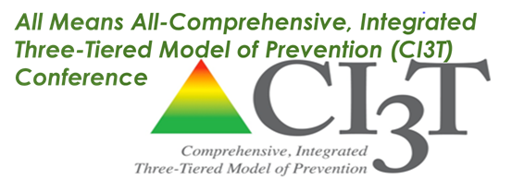

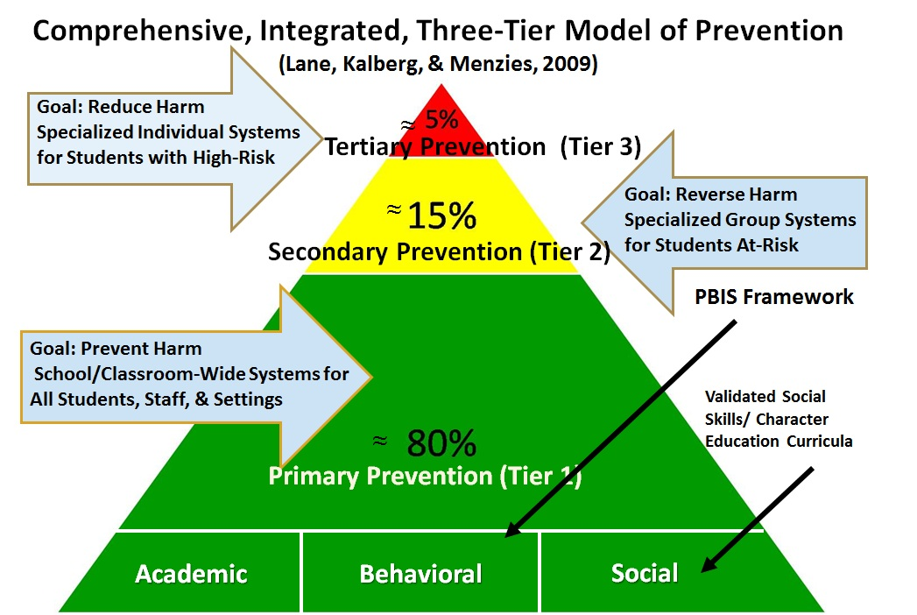
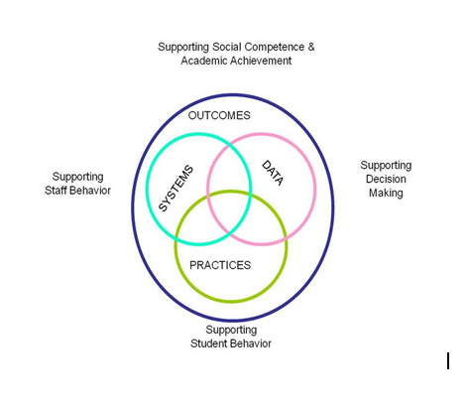
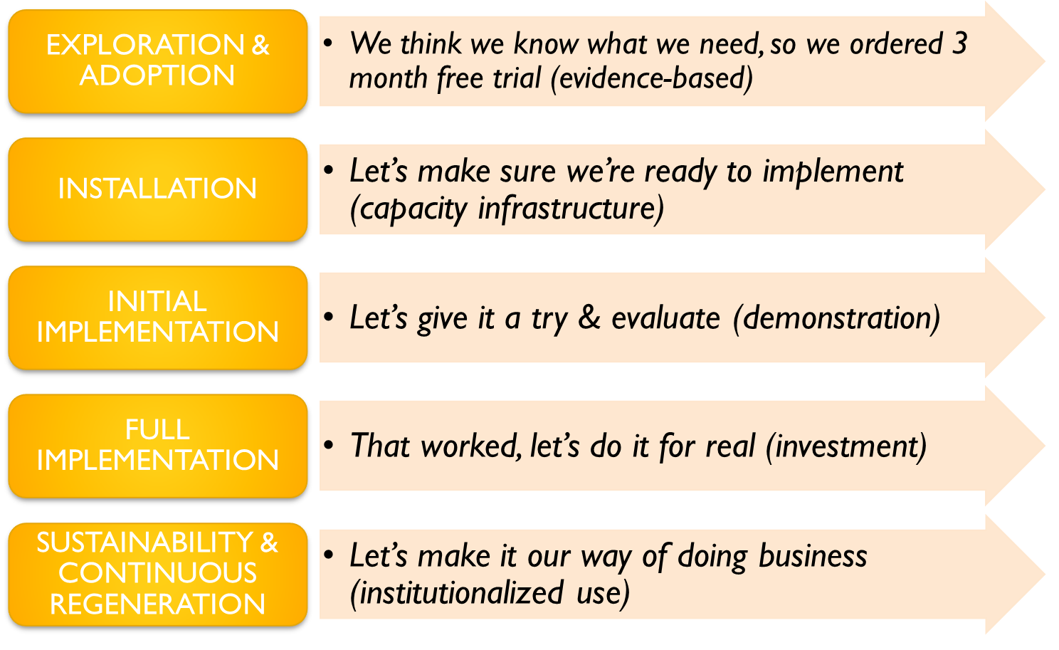

Handouts & Presentations
Available for download at www.allmeansall.weebly.com
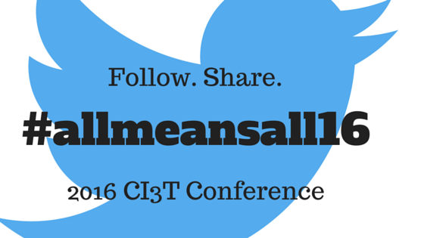
Follow the Learning
Follow and contribute to the conversation on Twitter with #allmeansall16
Wi-Fi Internet Access
Complimentary Wi-Fi is available for all institute attendees!
Connect your device to: Network SSID: SSD_LC_GUEST
Password: We take pride in our work!

Photo Booth
Gather your team for a picture at our photo booth during the day.
The photo booth offers a fun, interactive experience and a memento for conference attendees.

Conference Survey
Please take a few minutes to complete the post-conference survey.
Your feedback is greatly appreciated and will help us mold future events.

Team Planning & Commitments for 2016-17
Review Session topics, and assign team members to attend sessions and complete the Individual Team Member Note-Taking Worksheet.
During Commitments for 2016-17, organize and integrate the learning by using the Note-Taking Worksheets to (a) report to your team what you’ve learned, and (b) work with your team to update your implementation action plan.

Thank you for attending the 2016 Ci3T Conference!
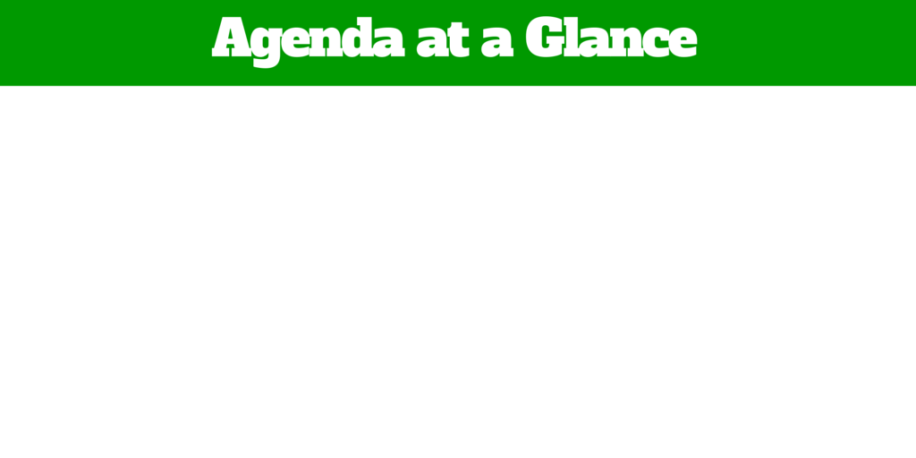
7:15 – 8:00 Morning Sessions

Room Session Presenter
3 Teaching Literacy Across Content Areas Nikki Shrum

4 High School Behavior Round Table Ryan Guffey & Tricia Diebold

8:30-10:00 A Look at Comprehensive Integrated Dr. Kathleen Lane,
Three Tiered Models of Prevention (Ci3T): University of Kansas
From Selection to Implementation

10:15-11:30 Breakout Session 1
Room Session Presenter
1 Access for Success Pat Van de Reit

2 Respectful and Responsible Ways of Responding Kathleen Lane
to Challenging Behaviors

3 Exploration of Supports and Strategies for Christy Thomas
Co-Teaching

4 Improving Reading Instruction Nikki Shrum

ABA Renew Awareness Ryan Guffey

11:30-12:45 Lunch
Room
1 CI3T Commitment Information, Q & A Kathleen Lane, Lisa Powers &
Taryn Gaskill
12:45 – 2:00 Breakout Session 2
Room Session Presenter
- Universal Design for Learning (UDL): Trish Diebold & Angela Cartee
Not Just Another Acronym

- Using Tiered Systems to Help Behavior Mikey Hughes, Lynn Baer &
More Trauma Sensitive, Part 1 Jamie Grieshaber

3 Math Strategies to Increase Your DO! Amanda Wise
4 Effective Writing Strategies Nikki Shrum
ABA Social Skills Instruction as Part of a Colleen Card & Kathleen Kras
CI3T Framework

2:15 – 3:15 Breakout Session 3
Room Session Presenter
- Positive Classroom Behavior Support Taryn Gaskill
2 More Trauma Sensitive, Part 2 Mikey Hughes, Lynn Baer

3 Family Partnerships for Student Success Michelle Levi-Perez

4 Problem Solving with Function in Mind Greg Hungerford & Ryan Guffey

ABA Wraparound Awareness Jamie Grieshaber

3:15-4:00 Team Planning/Organize & Integrate

Morning Session
Teaching Literacy Across the Content Areas
Outcomes: Participants will obtain strategies for teaching reading across content subject areas within a multi-tiered system of support.
Strand: Academic
Target Audience: Middle School/High School
Presented by: Nikki Shrum
Room 3

High School Round Table: A Behavioral Conversation
This round table discussion will facilitate a conversation and opportunity to network for high school staff members to surface strengths, needs, and potential next steps in an instructional approach to behavior at the secondary level. Participants will also be provided resources to help build the systems of support with their own building.
Outcomes: Participants will have the opportunity to network, learn from colleagues, and ask question around building a behavioral support system in high school building. Participants will be able to access a variety of existing resources, and advocate for potential training needs and supports for the future.
Strand: Social and Behavior
Target Audience: All Implementer with High School Focus
Presented by: Ryan Guffey & Tricia Diebold
Room 4
​Breakout Session 1
Access for Success
This session will identify effective processes and practices that will produce results to further the inclusion of individual children with disabilities into activities, routines and environments of their same age peers in their school.
Outcomes: Participants will identify roles and responsibilities of a collaborative team. Participants will review Collaborative Record Forms. Participants will identify processes of a MAPS and Curriculum Matrix for an individual student with disabilities.
Strand: Academic
Target Audience: All Implementers
Presented by: Pat Van de Riet
Room 1
Respectful and Responsible Ways of Responding to Challenging Behaviors
This session will focus on respectful and responsible ways of responding to challenging behaviors with emphasis on the importance of maintaining an instructional approach to behavior. Clarification of consequences and practical, effective, research-based strategies for responding when behavior challenges occur will be discussed.
​Outcomes: Learn about the balance of proactive and reactive strategies for supporting desired behavior in schools, with an emphasis on understanding acting out behavior · Develop the ability to clarify the role of consequences · Identify practical, effective, research-based strategies for responding to challenging behaviors
Strand: Academic and Behavior
Target Audience: All Implementers
Presented by: Kathleen Lane, University of Kansas
Room 2 (Streaming Live)
Exploration of Supports and Strategies for Co-Teaching
This session will provide an opportunity to explore resources co-teaching partners can use to create a strong working relationship with clear communication and expectations. We'll also introduce a tool for co-planning, and take a look at resources to support the goal of co-teaching - differentiated instruction
Outcomes: Participants will learn about supports they can use to enhance their co-teaching partnerships and strategies for planning for differentiated instruction.
Strand: Academic
Target Audience: General and Special Educators
Presented by: Christy Thomas
Room 3
Improving Reading Instruction
This session will explore the five areas of reading while highlighting strategies and resources for those areas.
Outcomes: Participants will obtain strategies for teaching the five areas of reading within a multi-tiered system of support.
Strand: Academic
Target Audience: General and Special Educators
Presented by: Nikki Shrum
Room 4
​Renew Awareness
Rehabilitation Empowerment Natural Supports Education & Work (RENEW). RENEW is a strengths based approach designed to support high school aged youth whom may be experiencing emotional and behavioral challenges. This supportive, student driven approach values the voice of the youth as they plan for their future and life after school.
Outcomes: Participants will learn about the RENEW principals and the desired outcomes of the four phase process. Participants will also learn about additional resources and next steps as they consider implementation in their school.
Strand: Academic, Behavior, Social
​Target Audience: High School Student Support Team, Administrators, Counselors, Social Workers
Presented by: Ryan Guffey
ABA Room

Breakout Session 2
Universal Design for Learning (UDL): Not Just Another Acronym
​This session will provide an overview of Universal Design for Learning as an instructional model. Participants will also have the opportunity to explore research and resources as they consider ways to implement into their own practices.
Outcomes: 1. Participants will be exposed to the basics of Universal Design for Learning (UDL) as an instructional model. 2. Participants will be able to access resources and explore implementation methods related to UDL.
Strand: Academic and Behavior
Target Audience: All Implementers
Presented by: Trish Diebold & Angela Cartee
Room 1
Using Tiered Systems to Help Behavior More Trauma Sensitive, Part 1
This session will provide an overview of trauma and the impact it might have on students, families and staff. Research that shows how trauma impacts brain and neurological development will be presented. Implementing a trauma-informed approach at the whole school level, small group, and individual levels will be presented. Outcomes: • Learn principles of Trauma Informed Care • Learn how to provide safety and security to all students • Educators will gain a trauma informed perspective to see the important of implement discipline in a sensitive, predictable and respectful manner as part of a tired systems framework.
Strand: Academic, Behavior, Social
Target Audience: All Implementers
Presented by: Mickey Hughes, Lynn Baer & Jamie Grieshaber
​Room 2 (Streaming Live)
Math Strategies to Increase Your DO!
In this session, participants will explore the relationship between the mathematical strategies described in the Missouri Learning Standards and the High-Yield Strategies by Marzano through hands-on activities they can use in the classroom tomorrow.
Outcomes: 1. Participants will understand the difference between a research-validated strategy and classroom activities. 2. Participants will be able to identify a classroom activity for each of Marzano's strategies.
Strand: Academics
Target Audience: General and Special Educators, Instructional Specialists
Presented by: Amanda Wise
Room 3
Effective Writing Strategies
This session will explore writing strategies and resources that can be implemented in a multi-tiered system of support.
Outcomes: Participants will obtain strategies for teaching writing within a multi-tiered system of support.
Strand: Academic
Target Audience: General and Special Educators, Instructional Specialists
Presented by: Nikki Shrum
Room 4
Social Skills Instruction as Part of a CI3T Framework
Participants will know the essential components of social skills instruction, where to access examples of social skills steps, basic structures for integrating social skills instructions at tiers 1-3, and strategies to use for students based on learning profiles (i.e. educational disability), and tools for monitoring social skills treatment integrity.
Outcomes:
Strand: Academic, Behavior, Social
​Target Audience: All Implementers
Presented by: Colleen Card & Kathleen Kras
ABA Room

Breakout Session 3
Positive Classroom Behavior Support: Overview of critical practices and decision-making guide
This session will identify critical positive classroom practices that came from the National Center's Classroom Technical Brief and how to embed in the classroom system.
Outcomes: Create an action plan for school-wide classroom management professional development and/or a plan to embed the critical practices within your classroom system of behavior support.
Strand: Academics and Behavior
Target Audience: General and Special Educators, Instructional Specialists
Presented by: Taryn Gaskill
Room 1
Using Tiered Systems to Help Schools Become More Trauma-Informed, Part 2 This session will provide an overview of trauma and the impact it might have on students, families and staff. Research that shows how trauma impacts brain and neurological development will be presented. Implementing a trauma-informed approach at the whole school level, small group, and individual levels will be presented.
Outcomes: • Learn principles of Trauma Informed Care • Learn how to provide safety and security to all students • Educators will gain a trauma informed perspective to see the important of implement discipline in a sensitive, predictable and respectful manner as part of a tired systems framework.
Strand: Academic, Behavior, Social
Target Audience: All Implementers
Presented by: Mickey Hughes, Lynn Baer & Jamie Grieshaber
​Room 2 (Streaming Live)
Family Partnerships for Student Success
This session is focused on improving outreach and collaboration with families and community partners. Participants will have a better understanding of the resources and supports available through Special School Districts Parent Education and Diversity Awareness Program.
Outcomes: 1. Participants will have a better understanding of the resources and supports available through SSD’s Parent Education and Diversity Awareness Program 2. Become familiar with Family Engagement strategies nationally and what’s happening at SSD 3. Become familiar with collaboration tools and resources 4. Commit to using one new family communication tool
Strand: Academic, Behavior, Social
Target Audience: All Implementers
Presented by: Michelle Levi-Perez
Room 3

Problem Solving with Function in Mind
This Professional Learning will support participants to use a simple, systematic approach for students with mild/moderate behavioral and academic needs. The process will guide the team to develop a support plan based on the function of behavior, as well as identifying data to monitor student outcomes. Participants will learn why to use a problem solving with function in mind process, function based interventions, process steps, and how to facilitate the conversation. Coaching support will be offered to participants as a follow up.
Outcomes: Know the rationale and when to implement Problem Solving with Function in Mind Know and be able to apply the steps for Problem Solving with Function in Mind
Strand: Academic, Behavior, Social
Target Audience: Tier 2 Coach, Grade Level Leaders, School Counselors and Psychologists
Presented by: Greg Hungerford & Ryan Guffey
Room 4
Wraparound Awareness
Wraparound is a strengths-based, unconditional and collaborative process grounded in family voice and choice, among other principles. With the family driving the process, the identified team will leverage the families strengths and needs to create one outcome-based plan.
Outcomes: Gain awareness of the evidence-based process of Wraparound; understand how it fits into a Multi-Tiered system of support; Make connections to their own work; know what next steps to take if wanting more information.
Strand: Academics, Behavior, Social
​Target Audience: Counselors, Social Workers, Behavior Experts, Tier 2/3 Coaches and Administrators
Presented by: Jamie Grieshaber
ABA Room

All resources from breakout sessions can be downloaded at www.allmeansall.weebly.com
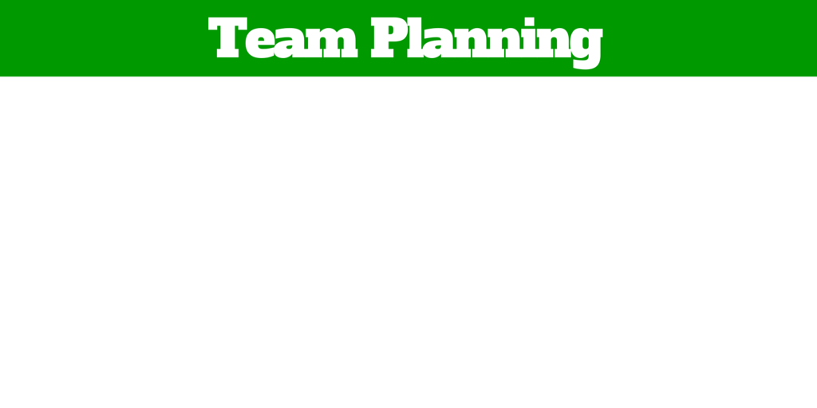
What Sessions Should We Attend?
Team Member | Session 1 | Session 2 | Session 3

Additional Notes (What do we hope to gain or learn today?)

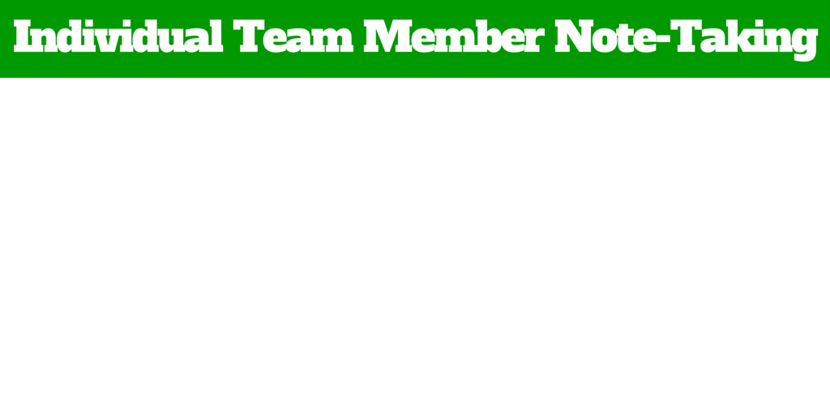

Keynote: |  | Presenter:  Kathleen Lane, University of Kansas
Evidence Based Practice:

Essential Feature:

Key Points to Presentation:

Take Back Points:
How will this information connect to a Comprehensive Three-Tiered Model of Support within your school?
Specific ideas to incorporate within my school(s):

Breakout Session Title: |  | Presenter:
Evidence Based Practice:

Essential Feature:

Key Points to Presentation:

Take Back Points:
How will this information connect to a Comprehensive Three-Tiered Model of Support within your school?
Specific ideas to incorporate within my school(s):

Breakout Session Title: |  | Presenter:
Evidence Based Practice:

Essential Feature:

Key Points to Presentation:

Take Back Points:
How will this information connect to a Comprehensive Three-Tiered Model of Support within your school?
Specific ideas to incorporate within my school(s):

Breakout Session Title: |  | Presenter:
Evidence Based Practice:

Essential Feature:

Key Points to Presentation:

Take Back Points:
How will this information connect to a Comprehensive Three-Tiered Model of Support within your school?

Specific ideas to incorporate within my school(s):
Team Planning/Organize & Integrate (How can we use what we learned to improve/enhance what we are doing?)
What are the big ideas we are taking away from today?
From these Big Ideas – What do we want to Accomplish?
How can we accomplish this?
When would we like to accomplish this? | Who will do it?

